Minutes of the Annual Village Meeting of Broughton Moor Parish Council, held in Broughton Moor Community Centre on Thursday 19th May 2022 at 7pm

Present: Parish Councillors Thomas Armstrong, Marjorie Harrison, David Sharp, Denise Scott and Stuart Henderson.
Also Present: County Cllr Keith Little, Mrs Lesley Dakers, Mrs Claire Howsen and Rev’d Judith Morgan (Parish Clerk)

Apologies for absence were received from Allerdale Borough Councillor William Pegram

The Chairman read his report to the meeting. A copy of the report is attached to these minutes as Appendix 1.
It was noted that, in addition to those named in the report, Mrs Lesley Dakers had assisted the Clerk in preparing documentation for the Diocese of Carlisle and Mrs Claire Howsen had helped with the Coffee Morning for Ukraine. The Council wished to record its thanks to both ladies.

There being no other business, the meeting closed at 7.07pm

247
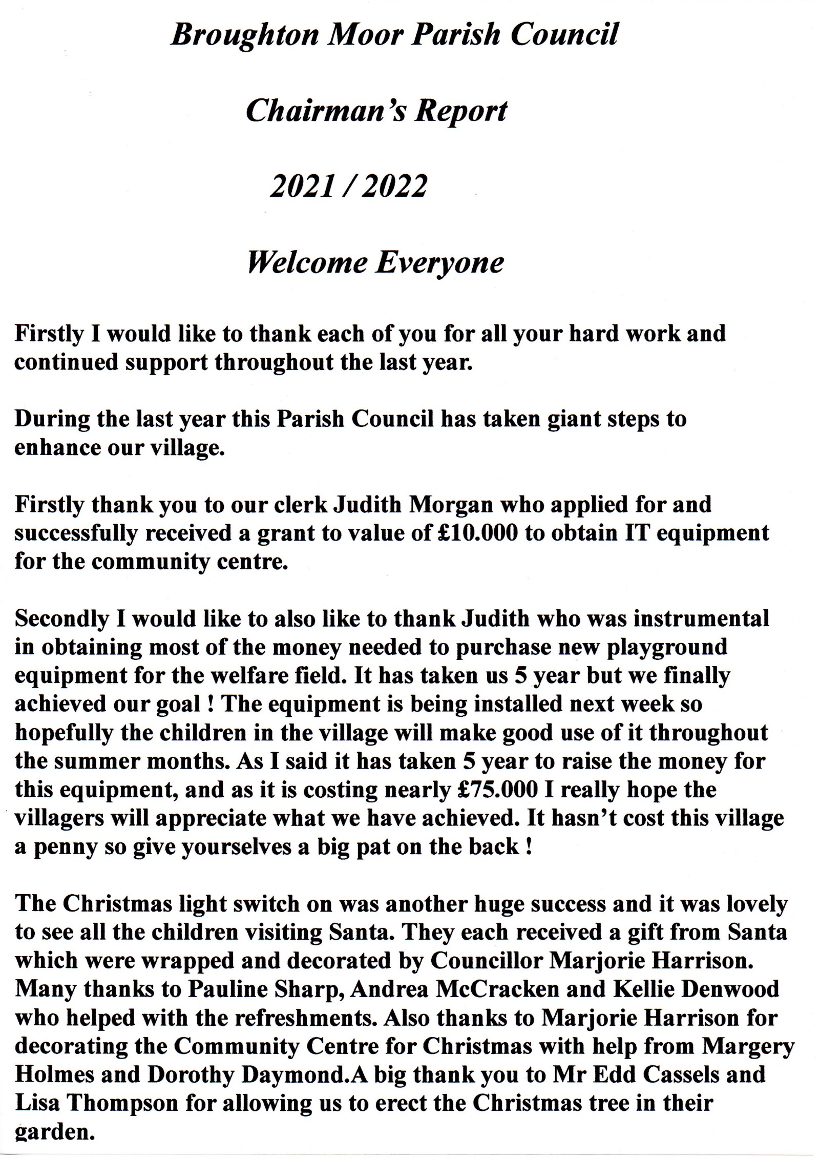
248
Appendix 1

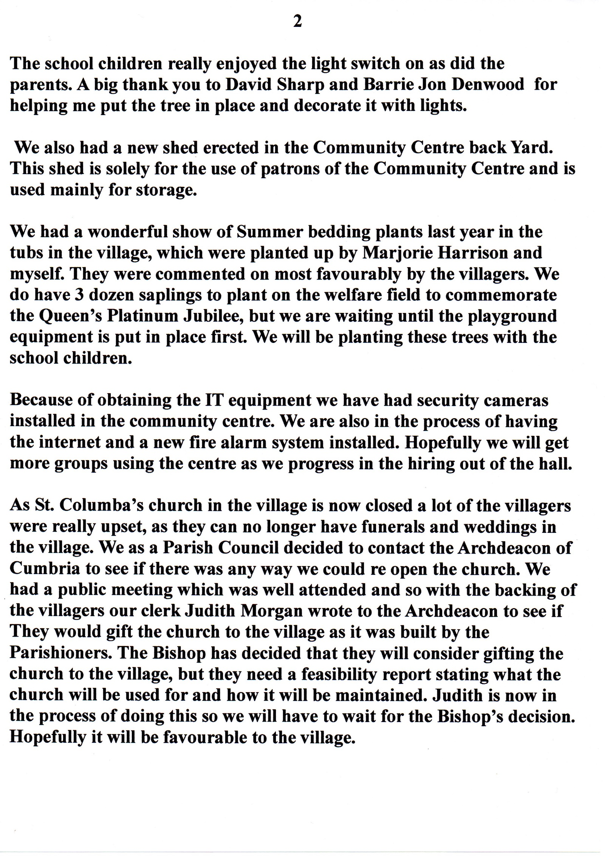
249
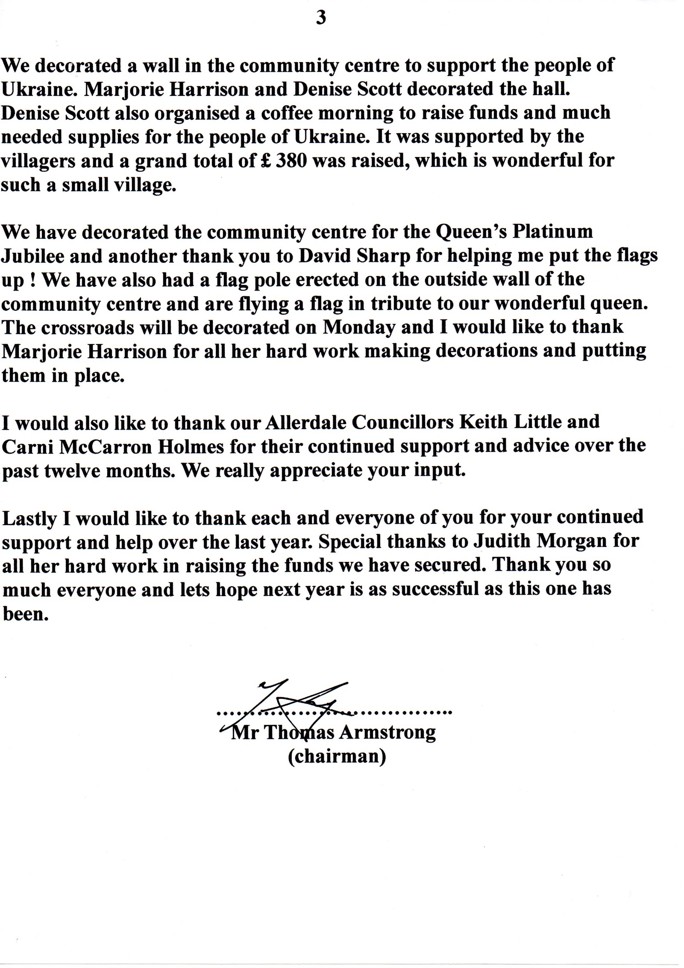
250
247

